FB03-DISPLAY FI DOCUMENT - DISPLAY FI DOCUMENT GENERATED FROM RECURRING ENTRIES



This simulation describes how to find FI documents posted through Recurring Entries periodic runs via T-code FB03.
Click to continue.

Explanation | Screenshot
[1] FB03 is now entered in the Transaction box. | 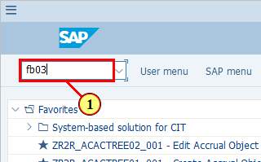
[2] You may also enter the individual document number in the "Document Number" field if you know the document number. This simulation will now describe how to find such documents if you do not know the document number.  Click Document List .  You can also press Shift+F8. | 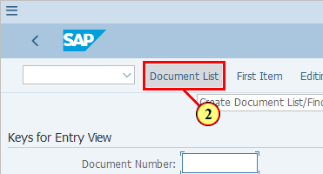
[3] Enter your company code in the Company code field. | 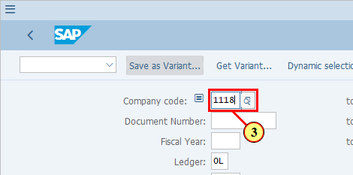
[4] Recurring Entries postings are ledger-through therefore you may leave the default ledger selection (0L) here. Alternatively you may remove it so that you can see the list of documents posted to all ledgers. | 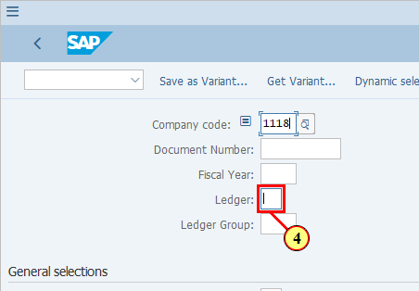
[5] You can use Dynamic Selections to filter for documents posted based on Recurring Entries.  Click Dynamic selections .  You can also press Shift+F4. | 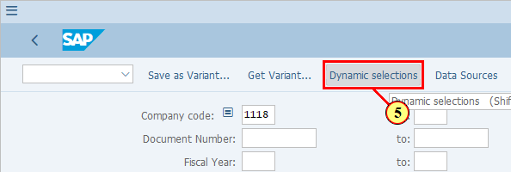
[6] If you receive a warning message like this, press Enter key to continue. | 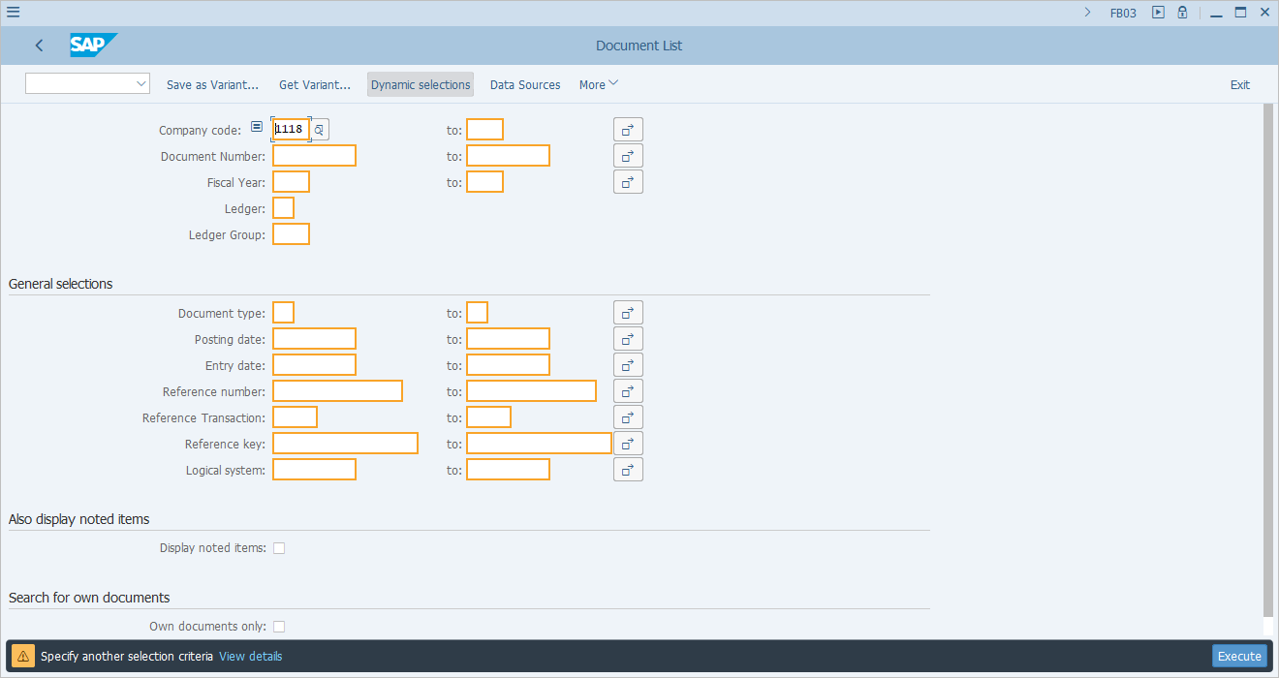
[7] Scroll down to locate field Recurring Entry Doc. | 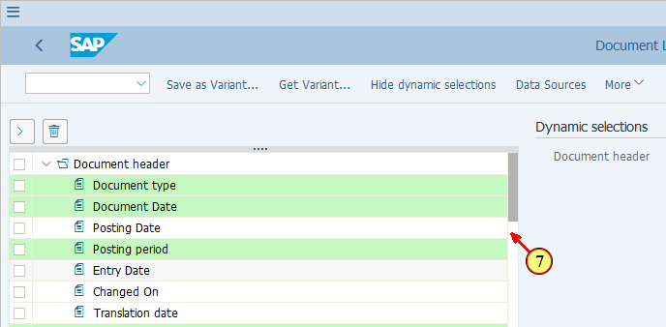
[8] Select this field by ticking the box . | 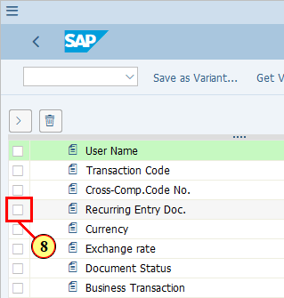
[9] Click TAKE to move the selection criterion to the right hand side of the screen. | 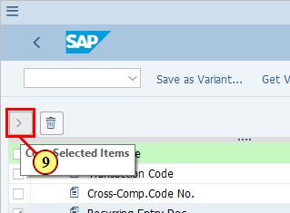
[10] Press ENTER key to continue if you receive warning message. | 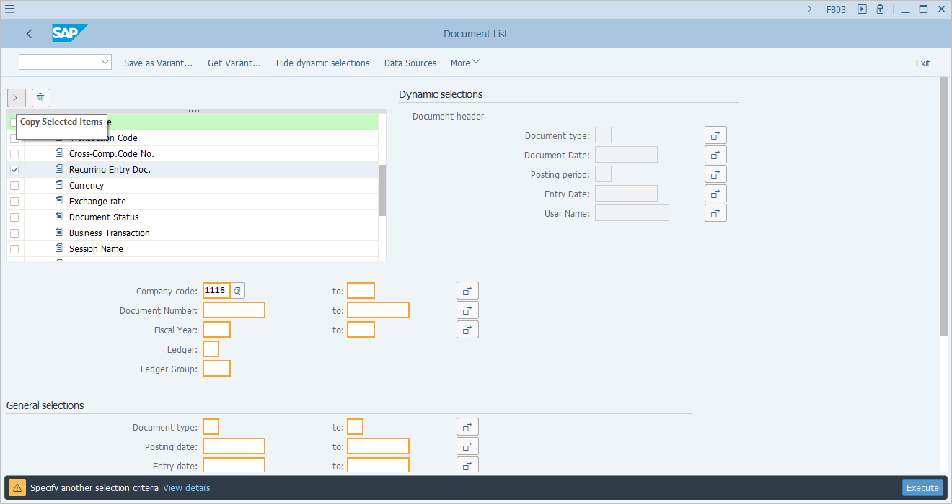
[11] Here, we want to put a selection condition that Recurring Entry Doc field is not blank.  To do this, double click the field Recurring Entry Doc. | 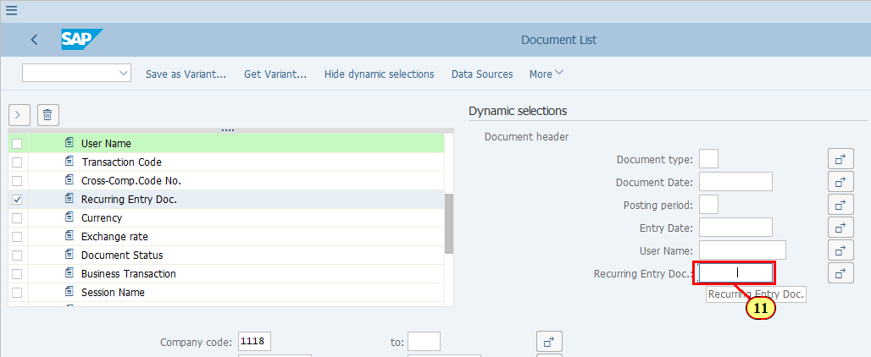
[12] Double click . This means we set a condition that this field should not equal to blank. | 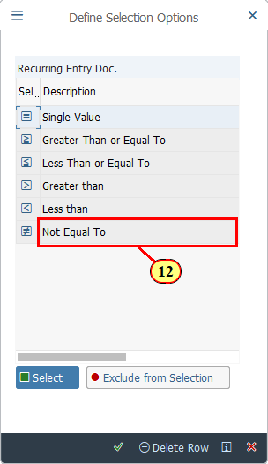
[13] Press ENTER to proceed if you recieve any warning message. | 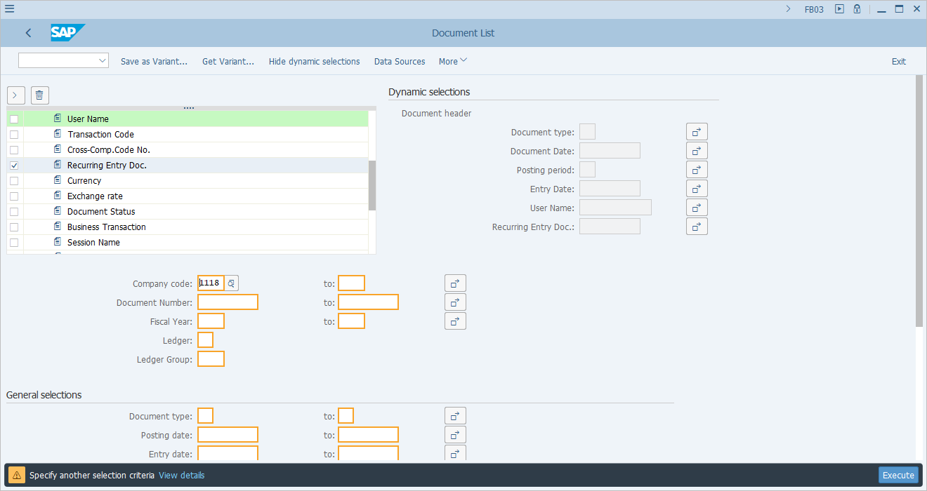
[14] Now continue with the standard selection criteria. E.g, you may select documents from a given year by entering the year in Fiscal Year field. | 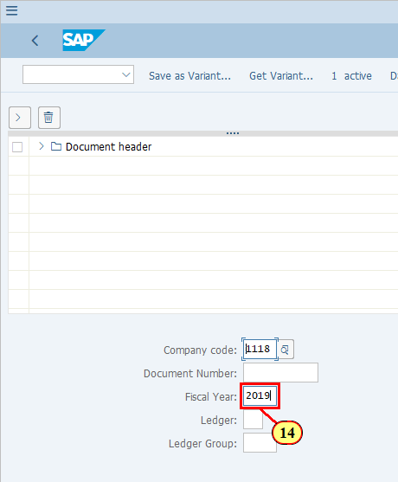
[15] You may also restrict the selection using Posting date fields. | 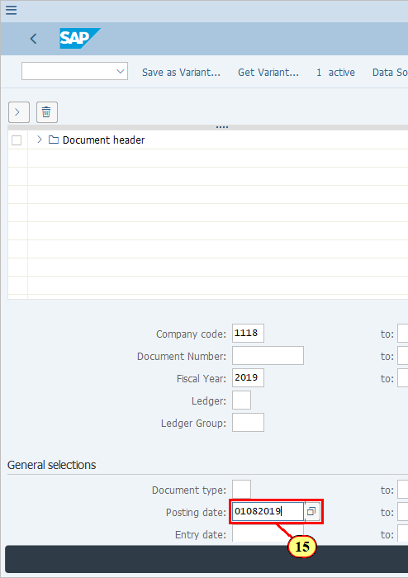
[16] The to field is filled out. | 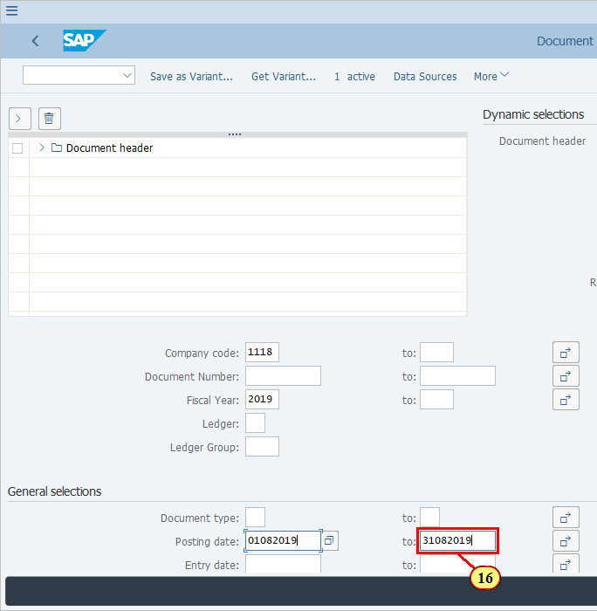
[17] Click Execute .  You can also press F8. | 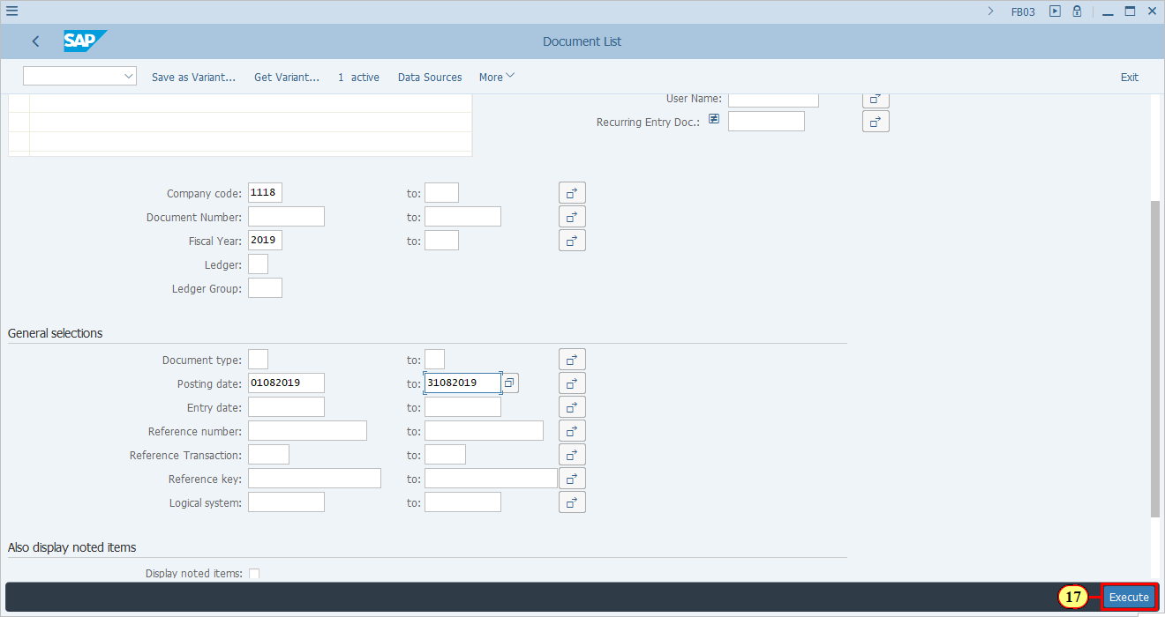
[18] Use Change Layout... . to change the layout in order to bring in the field "Recurring Entry Doc." to display.  You can also press Ctrl+F8. | 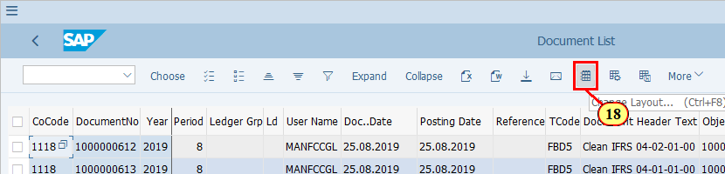
[19] Locate Column Name and click on it. | 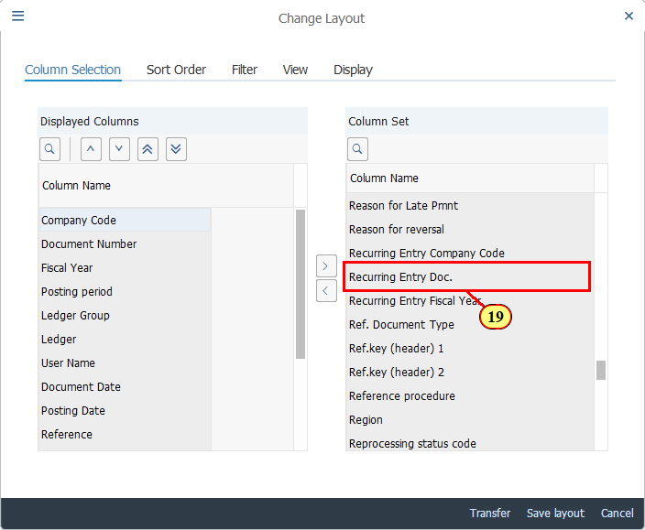
[20] Click Show Selected Fields to move this field to the columns that will be displayed.  You can also press F7. | 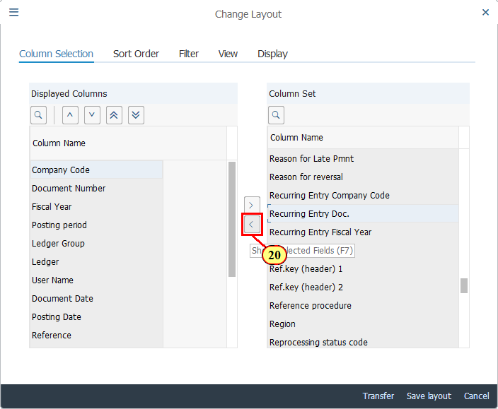
[21] Click Transfer .  You can also press Enter. | 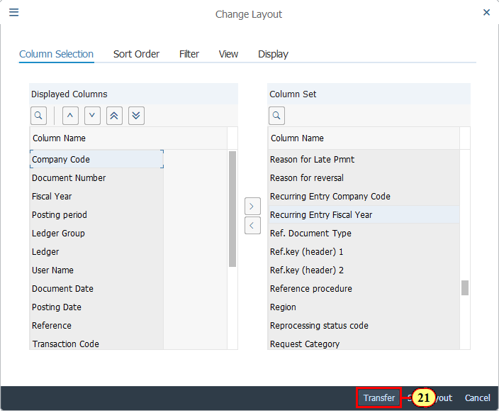
[22] Now you can see the corresponding Recurring Entry Document number of each of the FI documents generated from periodic runs of Recurring Entries.  To see details of a given FI document, double click on the corresponding DocumentNo. | 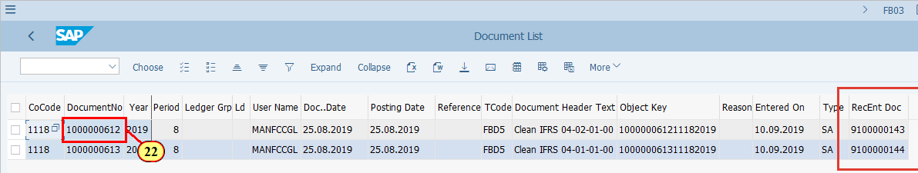
  You should notice that Ledger Group is blank, which means Recurring Entry documents are posted ledger through. | 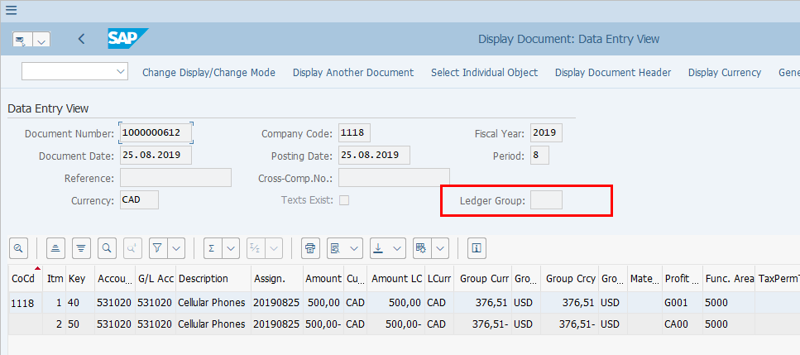
[23] Click Display Document Header .  You can also press F5. | 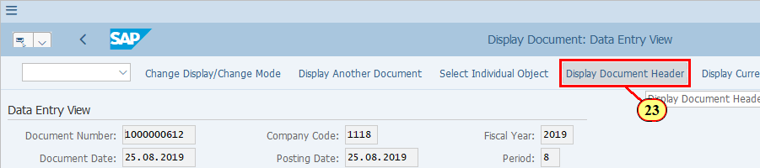
[24] The field indicates that this document was posted via FCC as Recurring Entry Periodic runs are posted via FCC during Period End. | 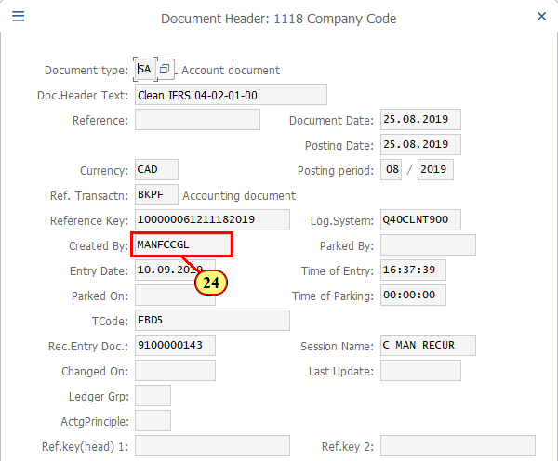
[25] The field Rec.Entry Doc. shows the original Recurring Entry document based on which the periodic recurring document was posted. | 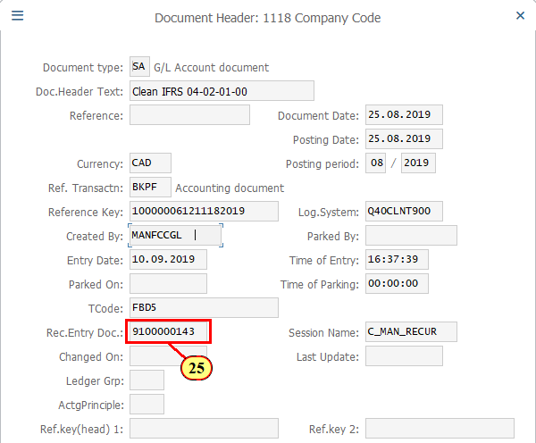
[26] Click Continue/Confirm .  You can also press Enter. | 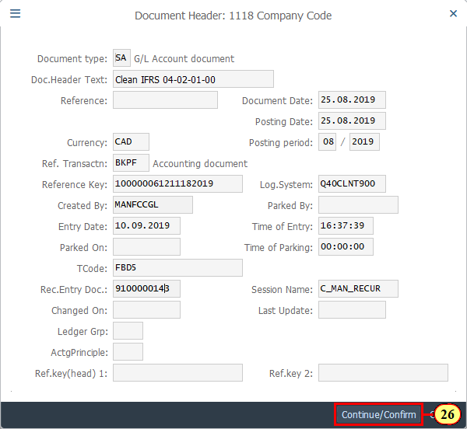
[27] Click General Ledger View .  You can also press Ctrl+F9. | 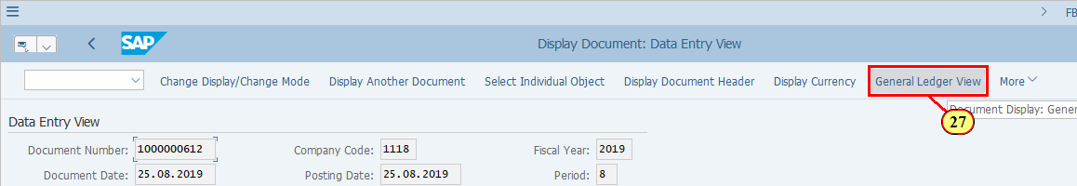
[28] Click Other Ledger .  You can also press Ctrl+F8. | 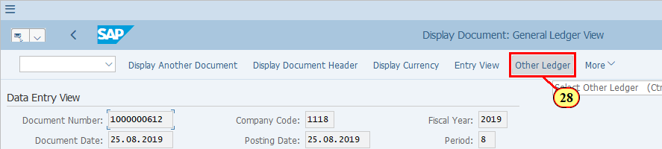
[29] You can see from here that the recurring entry posting was made through all ledgers at the same time.  Click Cancel .  You can also press F12. | 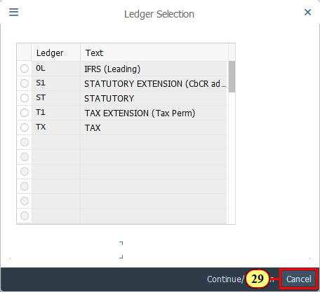
  You may also review the posting date, further document header and line item details, which are based on the original Recurring Entry document selected for Periodic posting of Recurring Entry documents. | 